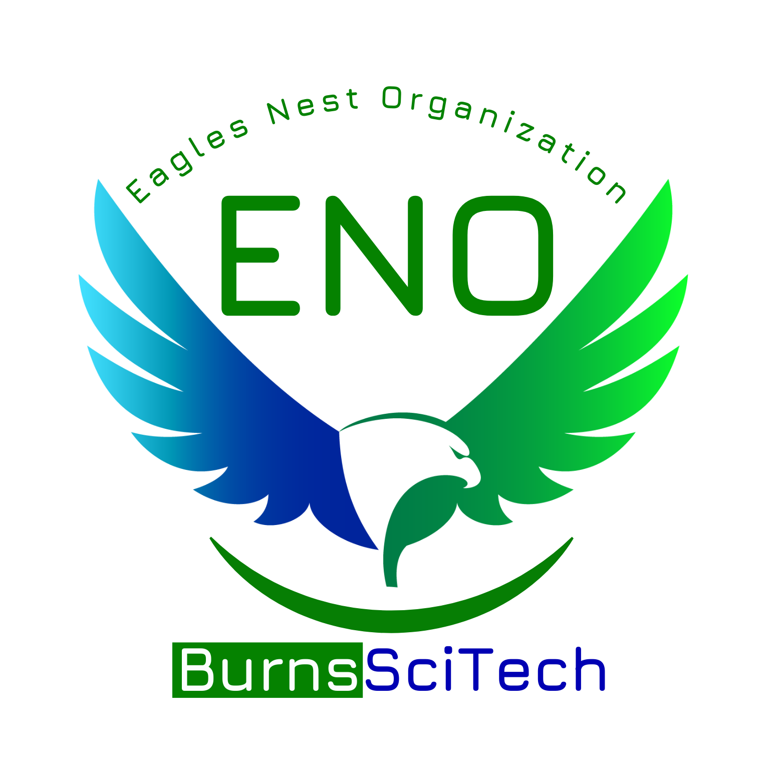Burns Science and Technology Charter School

**The Eagles Nest Organization**

General Membership Meeting

Friday, October 6, 2024

8:30am - minutes

| President: Cameron Calkins | Secretary: Megan Cooper |
| --- | --- |
| Vice President: Katie Fynes | Treasurer: Sydney Jenkins |

1. **ENO Updates & Officer Reports**

* President’s Report
* Teacher Needs Survey- volunteer request form on website
* Treasurer’s Report
* Current Balance - $15,256.38
* Audit Consultation by Haley Robinson, CPA; 3 volunteers for Audit Committee
* Principal’s Report
* Wranglers Ball, Friday, October 11, 6pm
* Story Book Parade, Thursday, October 31
* Pizza with the principal quarterly
* Hurricane relief

1. **Teacher and Staff Appreciation Committee**

* Teacher and Staff Appreciation Days
  + School Guardian Day- Wednesday, October 16
  + Substitute Teacher Appreciation Week- November 18-22
  + Literacy Week, Reading Coaches- November 18-22
  + National Special Education Day, ESE Teachers- December 2
* Stock the Staff Room
  + Reno planning in process
* Holiday Gifts
  + Need ideas!

1. **Student Recognition and Encouragement Committee**

* Safety Patrol Lunch October 18
* Upcoming testing volunteers

1. **Fundraising Committee**

* Penny Wars - HUGE Success - $3,987 raised. Funds are earmarked for a Book Vending Machine.
* Chick-Fli-A Spirit Night - $198.80
  + Chipotle in December 4th
  + Brooke Appy to help plan one more this semester
* Wreaths Across America Campaign, October 15 - December 3, Wreath Laying December 14
  + Student volunteer opportunity
* Save the Date: Scholastic Book Fair, November 18 - 22- Literacy week
  + Literacy Night- book donations
  + Student Video fundraising for books- Friday before literacy week

1. **Giving Committee**

* Teacher Grants - Action Items
  + Share book list to parents for Leader in Me donations
* Family Fun Bowling Day, November 16, 11am-1pm
* October 26- garden cleanup

1. **Other Business**

* Pop Tabs and Ronald McDonald House- send out reminder to collect pop tabs- share to Facebook page
* Box Tops for Education -website with receipt scan in

1. **Committee Breakout Session**
2. **Adjournment** Next Meeting: Friday, November 1, 8:30am