Burns Sci-Tech Charter School

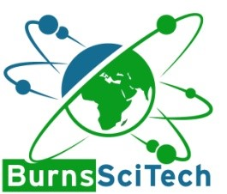

# Workshop Agenda

March 25, 2025 – 4:00 pm HS Makerspace

1. Call meeting to order.
2. Pledge of Allegiance.
3. Roll Call
4. Reports and Discussions:
   1. Board of Director Interviews with prospective board member applicants.
5. Kylee Montgomery
6. Sheneya Allen
7. Darcia Bair
8. John Drake
9. Jamie Sulle
10. ?
11. Charlotte Gillis
12. Adjournment.