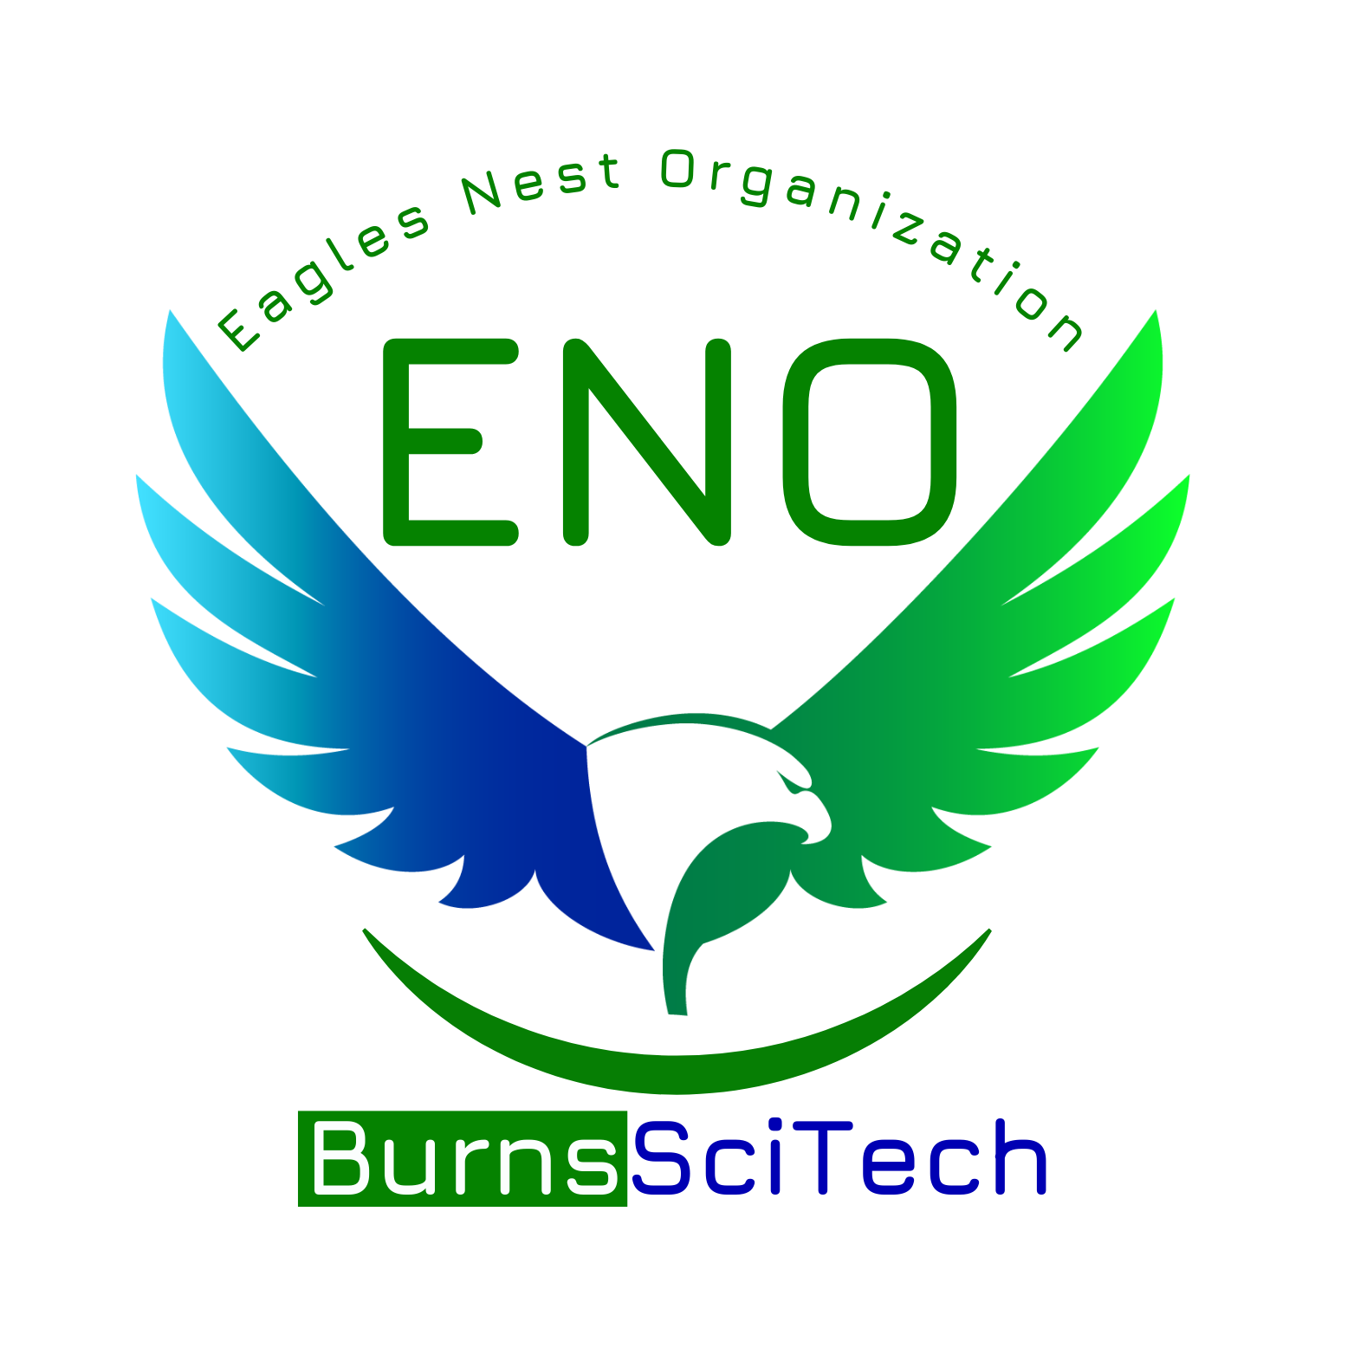Burns Science and Technology Charter School

**The Eagles Nest Organization**

General Membership Meeting

Friday, November 1, 2024

8:30am

| President: Cameron Calkins | Secretary: Megan Cooper |
| --- | --- |
| Vice President: Katie Fynes | Treasurer: Sydney Jenkins |

1. **ENO Updates & Officer Reports**

* President’s Report
* Treasurer’s Report - Current Balance: $12,475.19 we received our check from Scholastic finally!
* Principal’s Report Wrangler’s Ball went well, final numbers soon. Meeting with zoning about portables this afternoon.

1. **Teacher and Staff Appreciation Committee**

* National Substitute Appreciation Week November 18-22 (Tuesday, November 19)
  + 11 substitutes
  + “You are the best sub” Katie will purchase and bring in-publix gc
* National Literacy Week November 18-22 (Monday, November 20)
  + Ms. Betz- Reading Intervention Pat is looking at her favorite thing sheet and will give Katie ideas, Katie will purchase
* National Special Education Day Monday, December 2
  + 10 ESE teachers + Ms. Rachel Blalok, speech therapist still need ideas for the ESE team
* School Board Month- January 2025
  + Start thinking of ideas

1. **Student Recognition and Encouragement**

* Eagle Hall of Fame boards in cafeteria for K-6th and gym for 7-12 recognizing top students from their houses and academic achievement Megan is working on-Tricia Tudeen helped with ideas
* SGA recognition lunch in the works Megan is working on

1. **Fundraising Committee**

* Wreaths Across America Campaign 11/4 - 12/3, $17 per wreath, $5 back to ENO need to pass out to organizations that will be helpful in selling, Kiwanis, the chamber, place of employment
* Scholastic Book Fair 11/18 - 11/22, Volunteer shifts 8am - 11:30am, 11:30am - 2:30pm book fair needs to open at 740am, need volunteers
* Literacy Night 11/21, 5pm - 7pm **Book Fair will be open!!** 30 minute time slots, need volunteers!
* Spirit Night @ Chipotle 12/4 5-9pm flyer will come out closer to date
* Minted Code - FUNDRAISEEAGLESNEST Flyers out soon you receive 20% off of your order and ENO gets 15% back, code is good all year!
* Holiday Store 12/15 - 12/20, Volunteers Needed more info coming out soon
* Company: Reindeer Lane Gift Shop, [www.reindeerlane.com](http://www.reindeerlane.com)
* “Crafters Corner” for homemade donated items, cash only

1. **Giving Committee**

* Teacher Grants
* Beauty and the Beast Sponsorship $120 voted and passed to do sponsorship
* Mrs. Scarsella - Pencil Sharpener $30.87 voted and passed
* Mrs. Beltram - Supplemental curriculum materials $173.51 voted and passed
* Family Fun: Bowling @ New Smyrna Lanes, Nov. 16, 11am-1pm $5 a person, includes shoes
  + Sign up and pre-pay. Will post on Band late next week working on sign up, 6 people per lane 1 hr time limit for each group of 6. Sign up will be 11am-12pm or 12pm-1pm. Sign up out soon

1. **Other Business**

* Mentoring Program If interested please reach out to Ms. Desimini for information,[desiminic@burnsscitech.org](mailto:desiminic@burnsscitech.org) , another training coming soon - fingerprinting required.
* ENO Participation and Engagement looking for ideas to help boost involvement from parents and guardians. Will have a ENO table at Literacy Night to hopefully reach families and sign them up.

1. **Adjournment**