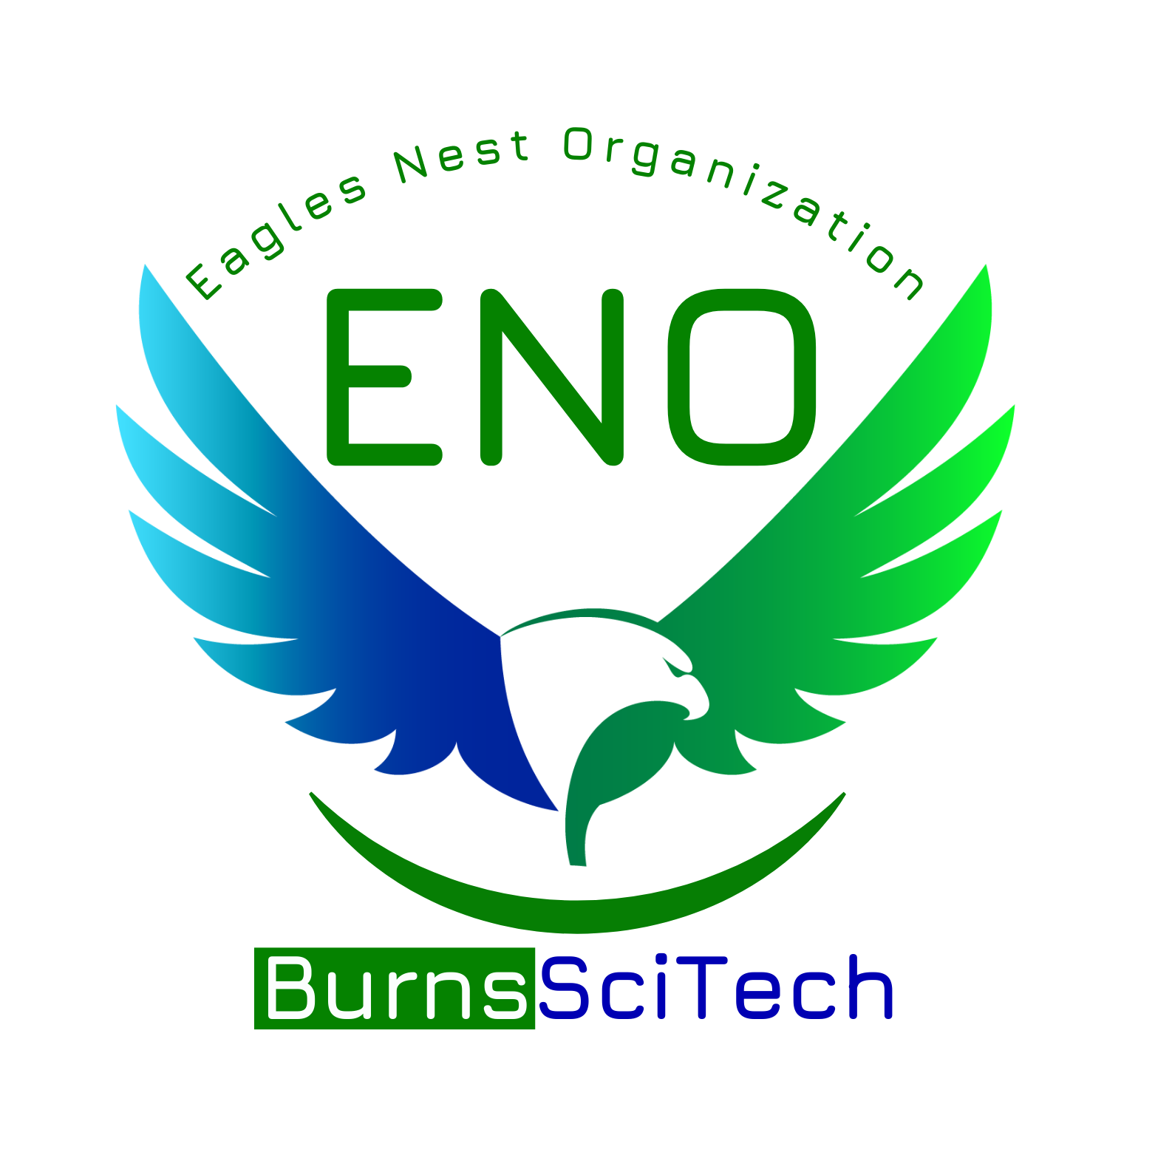Burns Science and Technology Charter School

**The Eagles Nest Organization**

General Membership Meeting

Friday, November 1, 2024

8:30am

| President: Cameron Calkins | Secretary: Megan Cooper |
| --- | --- |
| Vice President: Katie Fynes | Treasurer: Sydney Jenkins |

1. **ENO Updates & Officer Reports**

* President’s Report
* Treasurer’s Report - Current Balance: $12,475.19
* Principal’s Report

1. **Teacher and Staff Appreciation Committee**

* National Substitute Appreciation Week November 18-22 (Tuesday, November 19)
  + 11 substitutes
  + “You are the best sub”
* National Literacy Week November 18-22 (Monday, November 20)
  + Ms. Betz- Reading Intervention
* National Special Education Day Monday, December 2
  + 10 ESE teachers + Ms. Rachel Blalok, speech therapist
* School Board Month- January 2025
  + Start thinking of ideas

1. **Student Recognition and Encouragement**

* Eagle Hall of Fame boards in cafeteria for K-6th and gym for 7-12 recognizing top students from their houses and academic achievement
* SGA recognition lunch in the works

1. **Fundraising Committee**

* Wreaths Across America Campaign 11/4 - 12/3, $17 per wreath, $5 back to ENO
* Scholastic Book Fair 11/18 - 11/22, Volunteer shifts 8am - 11:30am, 11:30am - 2:30pm
* Literacy Night 11/21, 5pm - 7pm **Book Fair will be open!!**
* Spirit Night @ Chipotle 12/4 5-9pm
* Minted Code - FUNDRAISEEAGLESNEST Flyers out soon
* Holiday Store 12/15 - 12/20, Volunteers Needed
* Company: Reindeer Lane Gift Shop, [www.reindeerlane.com](http://www.reindeerlane.com)
* “Crafters Corner” for homemade donated items, cash only

1. **Giving Committee**

* Teacher Grants
* Beauty and the Beast Sponsorship $120
* Mrs. Scarsella - Pencil Sharpener $30.87
* Mrs. Beltram - Supplemental curriculum materials $173.51
* Family Fun: Bowling @ New Smyrna Lanes, Nov. 16, 11am-1pm $5 a person, includes shoes
  + Sign up and pre-pay. Will post on Band late next week

1. **Other Business**

* Mentoring Program
* ENO Participation and Engagement

1. **Adjournment**